**Objective:**

To design and implement a radar-based object detection system using Arduino, HC-SR04 ultrasonic sensor, servo motor, RGB LED, buzzer, and Processing IDE to visualize objects and measure their distance within a defined arc.

**Components Used:**

* Arduino UNO board
* HC-SR04 Ultrasonic Sensor
* Servo Motor (e.g., SG90)
* RGB LED (Common Cathode)
* Buzzer
* Jumper wires and Breadboard
* Resistors (3 × 220Ω for RGB LED)
* USB Cable (for Arduino)
* Personal Computer (for Processing IDE)

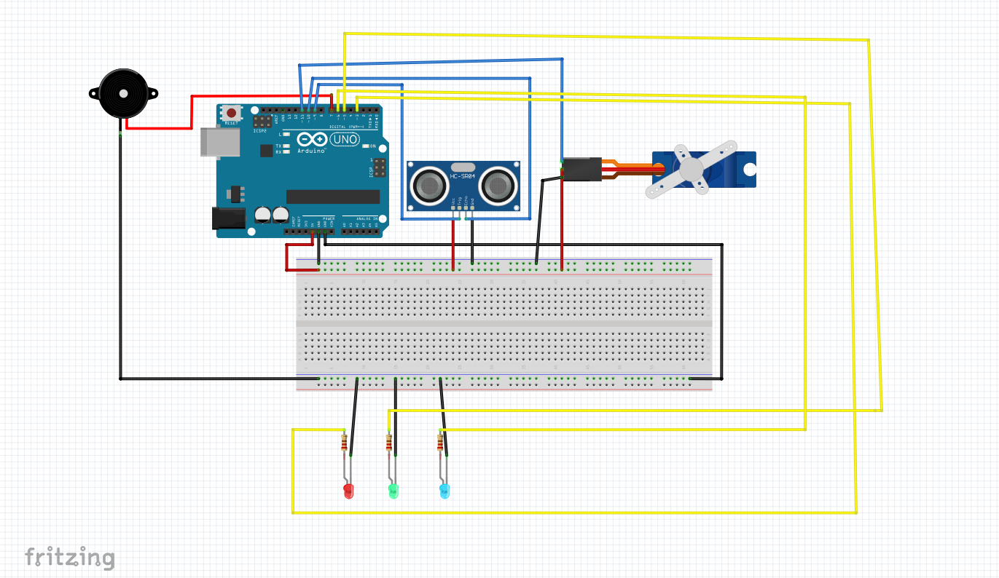

**Circuit Diagram**

**Theory:**

This project mimics a basic radar system using an **ultrasonic sensor** mounted on a **servo motor**. The sensor rotates from 0° to 180° and back, scanning for nearby objects. The distance and angle data are sent from Arduino via serial communication to the **Processing IDE**, where it is visualized in a **radar-like interface**.

The **HC-SR04 ultrasonic sensor** uses sound waves to detect objects. It emits ultrasonic pulses and calculates the distance to an object based on the time it takes for the echo to return. A **servo motor** sweeps the sensor across an angular range, and the **Processing software** simulates a radar display.

An **RGB LED** provides color-coded alerts based on distance:

* Red: Object within 20 cm
* Green: Object within 30 cm
* Blue: Object within 40 cm

A **buzzer** activates when an object is very close (≤10 cm), simulating a proximity alert.

**Applications:**

* Home/Office security systems
* Obstacle detection for robotics
* Entry monitoring at doors or windows
* Motion tracking and detection systems
* Object mapping in small-scale environments

**Future Advancements:**

* Replace ultrasonic sensor with **LiDAR** for higher precision and range
* Add **wireless communication** (e.g., Wi-Fi or Bluetooth) for remote monitoring
* Use **camera module and image processing** for object identification
* Integration with **IoT** platforms for real-time alerts via mobile devices
* Upgrade to **360° scanning** using a continuous rotation servo or stepper motor

**Application in Mining:**

* **Proximity detection** of personnel or equipment in underground tunnels
* **Obstacle sensing** in confined mining environments
* Assist in **automation of mine equipment** by mapping surroundings
* Enhance **safety systems** in shafts or haulage roads
* Detect **cave-ins or movement** in high-risk zones using reflective object detection